Most… Important Battles in WWI
World War I (WWI) was also known as “the Great War”. The scale of destruction and death had never been seen before. Look at the images below, and see what you can infer from them. How and where was WWI fought?
1.WWI Cartoon of Major Powers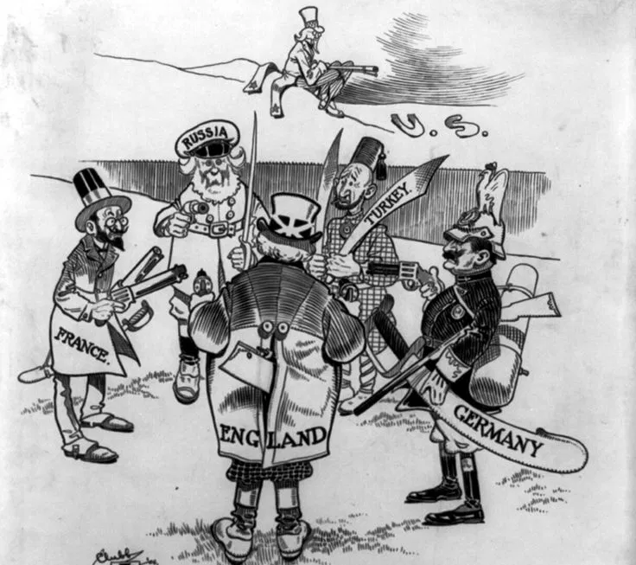 | 2.Battle of the Somme, 1916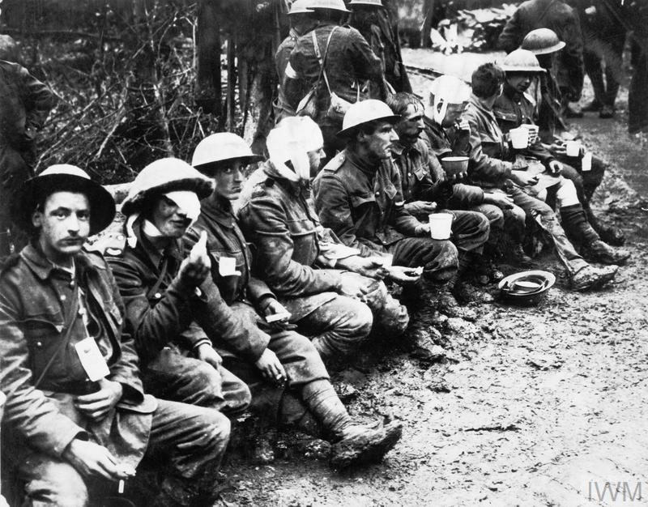
3.Image from film: 1917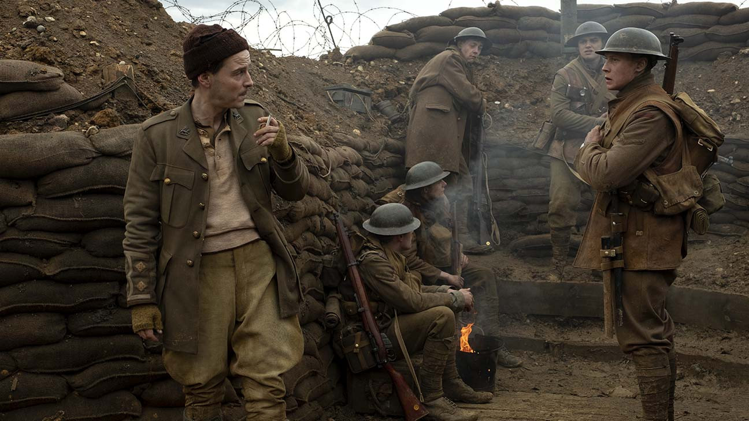 | 4.The Eastern Front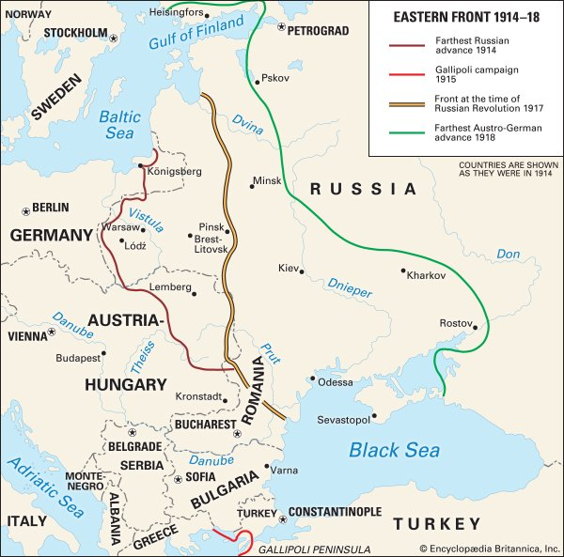
Write down some assumptions you have about how and where World War One was fought.
Initial Assumptions: | Revised Statements
But Some… 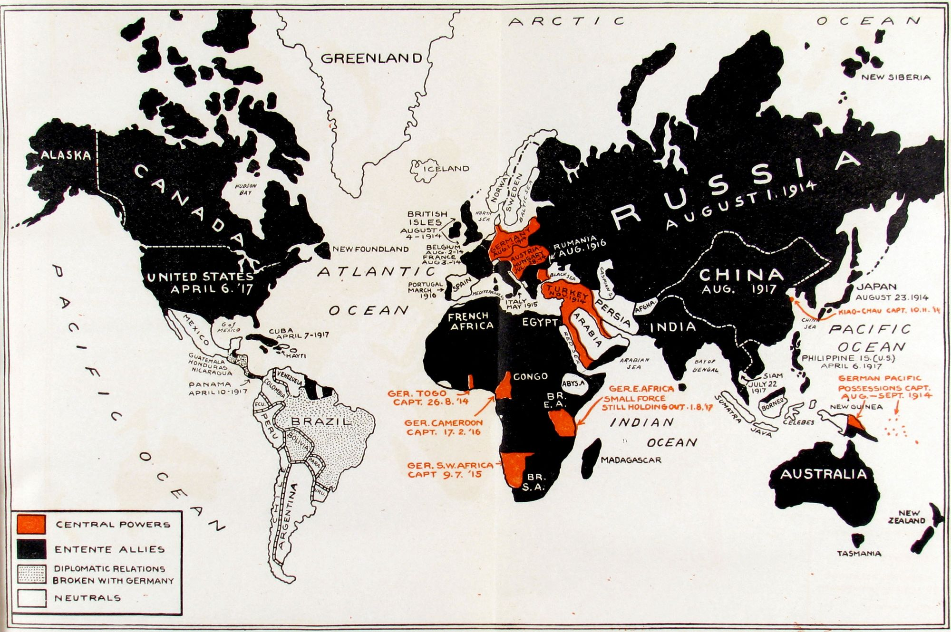
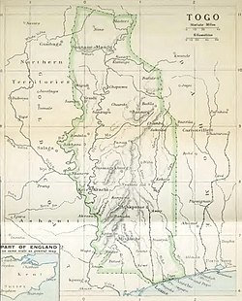
Battle of Chra, 1914
The Battle of Chra (22 August 1914) was fought by British and French soldiers against German soldiers and armed police. Chra was a village in Togoland - a German colony located in West Africa.
The British government declared war on Germany on August 4th. The next day the government decided that continued British dominance of the sea was to be a priority. Within days French police had captured customs posts in Togoland and taken over local towns, often with the support of local residents who wanted to get rid of German forces. The British flag was raised and on 9 August, with soldiers having marched 50 miles in exhausting heat. From there, soldiers moved towards a wireless radio station in Kamina. German soldiers tried to weaken the oncoming soldiers by blowing up bridges and digging around other entry points. The British forces suffered, and Lieutenant George Thompson became the first British officer to be killed in action in the First World War. While the German forces were able to gain an advantage over the British soldiers, French soldiers were approaching from the north. On the morning of 23 August, the British found that the German trenches had been abandoned - when they reached Kamina on the 26th they had found that many German soldiers had deserted, with the rest surrendering.

The Battle of Coronel and the Battle of the Falklands, 1914.
In late 1914, both the British and German empires had territories in the South Pacific Ocean. The British Empire needed to keep trade flowing to Australia and New Zealand to support the war effort, however the German Empire sought to disrupt this trade. To counter this, the Royal Navy began to scout for the large German Fleet that threatened the access to the South Pacific.
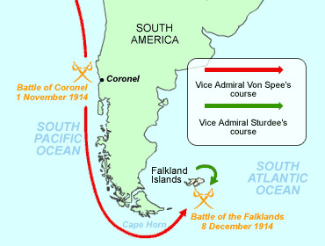
A British patrol fleet met the German squadron off the coast of Chile on the 1st November 1914. The Battle of Coronel was a short and decisive victory for the larger German fleet. Having sunk 2 British armoured cruisers for merely 3 German sailors wounded. This shocked the British public immensely, as they thought the Royal Navy were the naval hegemony. Not to be humiliated, the Royal Navy sent a large task force to hunt the German squadron down.

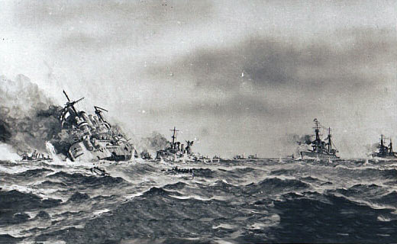
The German squadron had been deceived by British code writers that Port Stanley on the Falklands was free of any Royal Navy ships. Consequently, the German fleet then set course to raid the port. This was intercepted by the British task force. The outdated German Squadron, which was Germany’s only permanent overseas fleet, was devastated by this modern task force on the 8th December. Losses amassed to 1,871 killed, 200 captured and 4 cruisers and 2 transport ships sunk. The Royal Navy dominated the South Pacific for the rest of the war.

A British postcard commemorating the victory at the Falklands, 1914

The Battle of Megiddo
The Battle of Megiddo (19-25 September 1918) marked the beginning of the final British-led offensive in the Sinai and Palestine Campaign. It successfully combined cavalry, infantry, artillery, armoured vehicles and aircraft to achieve a decisive victory over the Ottoman Turks and their German allies. It was the start of a series of important Allied victories that ultimately led to the collapse of Ottoman Turkish forces and their eventual withdrawal from the war.
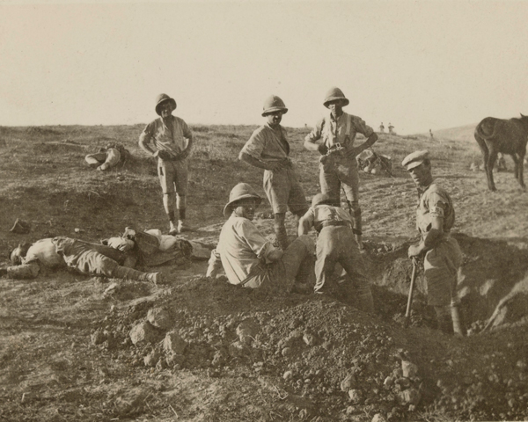
Soldiers burying Turkish dead near Beersheba, November 1917
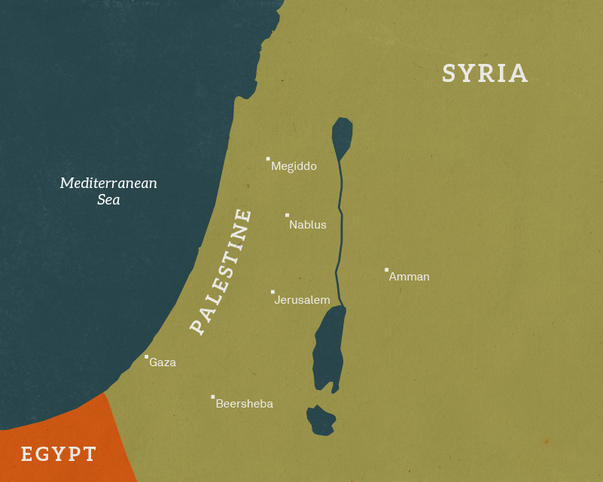
The offensive opened with an intense but brief artillery bombardment. British and Commonwealth forces quickly broke through the battered Ottoman lines with an advance of over 30km on the first day. The Desert Mounted Corps then quickly pushed through gaps in the defences to encircle the Ottoman troops. The Ottoman Eighth and Seventh Armies collapsed under the pressure of the Allied attack, surrendering in the tens of thousands
Victory at Megiddo opened the way to Damascus, which Australian troops entered on 1 October. In the weeks that followed, the Allies captured other strategically important cities. On 30 October, the Ottoman Empire sought a peace settlement with the Allies and an armistice was signed at Mudros, with hostilities ceasing at 12 noon the following day. This was also after Turkish forces were defeated by Britain and its allies in Mesopotamia.

What have you learned about how and where WW1 was fought? Rewrite your statements, now armed with new historical knowledge.

Written by: George Beard, Tom Crawford, Alex Ellwood.

