Whose Histories?
Helping busy history teachers keep their curriculum diverse

This short guide has been created by the University of York’s PGCE history trainees in a morning session where they thought about diversity and explored what resources are available. It contains their thoughts for some general principles and ideas for making lessons more diverse, with links to resources they think will be helpful. It is not intended to be exhaustive, but to be a contribution to help busy teachers. It is divided into sections as follows:
- General principles
- Queer history
- Asian history
- Gypsies, Roma and Travellers
- Black History
- Polish history
- Disability history in your classroom

General Principles for Best Practice

- You need to have a background understanding of the group including confident use of appropriate terminology. It’s poor practice to pronounce terms incorrectly or use terminology under-confidently - that perpetuates the idea of the ‘other’ and perpetuates unconscious prejudice. There are people and online modules who will help you if you feel underconfident approaching a topic – avoidance is not acceptable either!
- Try not to teach diverse histories as bolt-on modules. Try to integrate the histories of diverse groups of people into the history you are already teaching. Acknowledge the multiplicity of the past and societies without quarantining it as a ‘separate’ history curriculum.
- Try to instil a strong chronological understanding to enable pupils to synthesise diverse histories into one timeline
- Don't shy away from using a wide range of historical sources; for example, oral histories and the archaeological record can offer an invaluable insight into previously invisible peoples/communities
- Approach the topic aware of contemporary contentious issues and debates around the subject and be prepared to address these in the classroom.
- Be aware of your own idea of the ‘normal’ and don’t be afraid to critique yourself.
Queer history in the Classroom

Queer history is something which is often forgotten about in the curriculum, largely due to the relative invisibility of their specific histories throughout time. Due to changes in the law and the changing prominence of this cultural aspect of society, it has become increasingly obvious that we do not discuss queer history, although there is a historiography we can draw upon. Young people in the classroom are more aware of the concepts of gender, sexuality and identity than ever before and it does them a disservice not to include the histories of LGBTQ+ people in our lessons. As history teachers we have the position to be able to teach our pupils about the wider history of LGBTQ+ people; allowing them to understand the modern issues within the context of past.

There are clear areas within the 2014 National Curriculum which provide possible areas for us to incorporate a greater proportion of Queer history within our KS3 lessons. For example:

- “The nature of ancient civilisations” and characteristic features of these ancient civilisations.
- The development of the Church, state and society in Britain, 1509-1745 → “society, economy and culture across the period”.
- Ideas, political power, industry and empire, 1745-1901.
- Challenges for Britain, Europe and the wider world 1901-present → “social, cultural and technological change in post-war British society”.
- Local history study → e.g. Anne Lister and Yorkshire.

We have identified four possible topics/areas for the inclusion of queer history within the classroom, in topics which are often taught in the KS3 history classroom. These are: the Romans; the Victorian ‘underworld’; the World Wars, and changes in post-war Britain.

For a general overview of the history of LGBTQ+ people across British history, see this link: http://www.wikiwand.com/en/Timeline_of_LGBT_history_in_the_United_Kingdom

For an excellent blogpost about teaching this history, please see: https://freshalarums.wordpress.com/2019/01/14/being-ambitious-with-lgbt-history/

For a broad overview of the history of LGBT in archives, please see:
https://blog.nationalarchives.gov.uk/lgbt-history-national-archives-library/

The Romans
- Artefacts - such as pottery
- Book: From Prejudice to Pride: A history of the LGBTQ+ movement (2017) - for Y7+ - useful for all of the following topics, but commences the survey in the Ancient Period
- http://www.ancientdigger.com/2012/05/pompeii-erotic-art-and-roman-sexuality.html
- https://www.youtube.com/watch?v=4bcyRJMDF2A - ‘LGBT Emperors of Ancient Rome’
- Homosexuality in Greece and Rome - Thomas Hubbard - a good collection of primary sources for Ancient Greence and Ancient Rome.

Medieval History
- Primary source materials on Fordham and are pretty much all accessible https://sourcebooks.fordham.edu/pwh/gaymidages.asp also has some suggestions for readings
- Lots of interesting illuminated manuscript images showing same-sex relationships in a somewhat “positive” light
- Ideas that homosexuality was seen as sinful only in 12th/13th C - in conjunction with the rise of canon law/wider anxieties within Medieval world/defining Catholic doctrine e.g. 1215 Fourth Lateran Council “legislates” about homosexuality; how the OT and NT are interpreted and what they say about “sodomy”.
- Seminal text on homosexuality in the MA = Boswell Thesis. Has been contested but important for kick starting this field
- Consequent collection of essays ed. Kuefler The Boswell Thesis: Essays on Christianity, Social Tolerance, and Homosexuality -
- Although not strictly LGBTQ+ - lots of interesting scholarship on medieval drag culture - often spoken about in terms of “cross dressing”

Ancient Greece
- History Extra: https://www.historyextra.com/period/ancient-greece/a-brief-history-of-sex-and-sexuality-in-ancient-greece/
- http://elysiumgates.com/~helena/Sexuality.html
- Book: Paul Chrystal, In Bed with the Ancient Greeks: Sex & Sexuality in Ancient Greece.
- Sparta as a case study.
- Greek Sources depicting Homosexuality, controversial topic of Pedagogical Pederasty: https://www.livius.org/articles/concept/greek-homosexuality/
- 2007 article by James Davidson for background contextual information https://www.theguardian.com/books/2007/nov/10/history.society
- Aristophanes- Lysistrata: Comedy and early exploration of Gender Politics (although not strictly LGTBQ, men would have played the female parts, engaging for a study of early cross-dressing and its historical purposes) https://en.wikipedia.org/wiki/Lysistrata

Early Modern History:
- Shakespeare plays: Similar to Aristophanes, men playing feminine parts on stage was considered the norm. Relevant to Cross-Dressing and its Historical Purposes
- Buggery Act 1533 - First civil sodomy law - remained a capital offence until 1861. https://www.bl.uk/lgbtq-histories/articles/the-men-killed-under-the-buggery-act
- Tower of London article - ‘LGBTQ+ royal histories’ https://www.hrp.org.uk/tower-of-london/history-and-stories/lgbt-royal-histories/#gs.p54rp0
- ‘Molly Houses - London’s Gay Subculture’ https://blog.britishnewspaperarchive.co.uk/2020/06/19/18th-century-molly-houses-londons-gay-subculture/

The Victorian Underworld
- Molly-houses → Mother Clap’s Molly house and trial could be used a case study
- Cleveland Street Scandal
- Anne Lister’s diary → history of lesbianism
- https://theyorkhistorian.com/2017/07/06/friendships-lesbianism-and-identity-in-victorian-britain/
- Oscar Wilde → his trial, and books such as The Picture of Dorian Gray

Modern Wars, and the soldiers of each army
- Homosexual emancipation movement in WW1 born out of the pre-war movement focusing on science to prove that homosexuality was biological
- Portrayal of WW1 by gay war poets e.g. Wilfred Owen and Siegfried Sassoon.
- Using letters to unpack the lives of gay men during WW2 http://www.bbc.co.uk/news/uk-england-38932955
- Stories of LGBT Men and Women from the First World War https://www.iwm.org.uk/history/stories-of-lgbt-men-and-women-from-the-first-world-war
- Case study: Alan Turing
- ‘Don't ask, don't tell’ policies of western armies in the late 20th century
- Homosexuality portrayed in World War Two films (The Iron Cross - 1977 film directed by Sam Peckinpah, Wehrmacht soldiers having homosexual relationships and the different attitudes of soldiers and officers - a short scene that can be used to introduce the topic)

Changes in post-war Britain
- Changes to the law (1967 sexual offences act from Wilson’s government legalised homosexuality, allowing homosexual relationships over the age of 21)
- Stonewall riots 1969
- Wider recognition of lesbianism/bisexuality/transsexuality
- York Castle Museum exhibit on identity and sexuality (near 1960s exhibit)
- Controversies between experience of LGBTQ+ acceptance in Britain/U.K - e.g. Northern Ireland
- UK Gay Liberation Front founded in 1970. The first ever pride march was in 1972. The GLF disbanded in 1973
- The terror and prejudice of the 1980’s AIDs crisis in the UK https://www.independent.co.uk/life-style/love-sex/aids-crisis-1980-eighties-remember-gay-man-hiv-positive-funerals-partners-disease-michael-penn-a7511671.html
- 1988: Section 28 passed by Margaret Thatcher which expressly denying local authorities the ability to support its LGBT constituents, funding was withdrawn from arts projects, while educational and resource materials which ‘prompt[ed] an alternative gay family’ were censored. This was enforceable until 2003. David Cameron issued a public apology for this in 2009.
- 2001 - legal age of consent for gay/bi men lowered to 16 from 18
- https://www.bl.uk/collection-guides/oral-histories-of-sexuality-reproductive-health-and-prostitution
- 2004 - UK Parliament passed the Gender Recognition Act which effectively granted full legal recognition for binary transgender people
- 2014 - Legalisation of LGBTQ+ marriage

Non-Binary and Gender non-conforming History:
- For a timeline of transgender history, please see: https://www.theproudtrust.org/resources/trans-resources/trans-history/
- A good article for the history of transgender: https://www.allaboutlaw.co.uk/commercial-awareness/legal-spotlight/the-history-of-transgender-rights-in-the-uk-
- February 1st 2020 article for overview of non-binary history https://thetempest.co/2020/02/01/history/the-history-of-nonbinary-genders-is-longer-than-you-think/#
- Review of Charlie McNabb, Nonbinary Gender Identities: History, Culture, Resources. (Lanham: MD: Rowman & Littlefield 2018) by Chris Babits https://elischolar.library.yale.edu/cgi/viewcontent.cgi?article=1065&context=jcas
- Trans Pioneers in Britain https://historicengland.org.uk/research/inclusive-heritage/lgbtq-heritage-project/trans-and-gender-nonconforming-histories/trans-pioneers/
- ‘Trans*: A Quick and Quirky account of Gender Variability’ by Jack Halberstam

General reading and resources to improve your own understanding
- https://www.amazon.co.uk/Sexuality-Very-Short-Introduction-Introductions/dp/0199298025
- https://muse.jhu.edu/article/12134/pdf
- http://www.stonewall.org.uk
- Would recommend watching Milk - ie first openly gay man to hold office in US, and his assassination
- Pride 2014 film: U.K. gay activists work to help miners during their lengthy strike of the National Union of Mineworkers in the summer of 1984.
- Overview of LGBTQ history https://www.bl.uk/lgbtq-histories/articles/a-short-history-of-lgbt-rights-in-the-uk?gclid=Cj0KCQiAlsv_BRDtARIsAHMGVSZSLHNqZfo9cZex7pQiJ9AhXYqt1AfZb3-MbRhUUEE06UIqdfsDADEaAmsdEALw_wcB#
- Timeline of LGBTQ history https://www.bl.uk/LGBTQ-histories/lgbtq-timeline

Incorporating Asian History into KS3 and KS4

If the challenge is teaching students of different religions, historical identities, and political positions, then the solution may lie in bridging those differences. - Larsen et al.

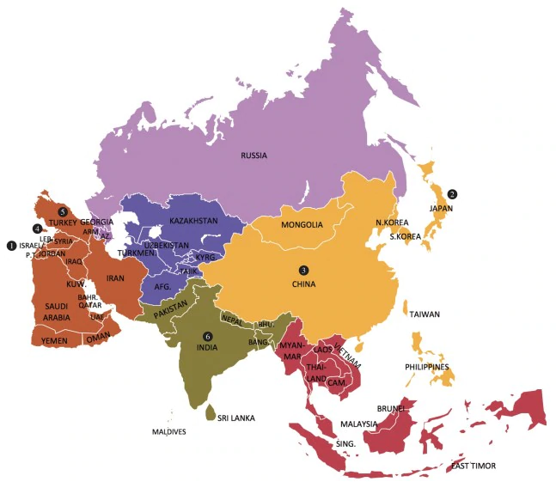

This is

As the largest continent in both area and population, the history of Asia and Asian peoples is hugely varied. To teach the histories of Asia effectively and respectfully it is important to recognise this. In addition it is vital to not view Asia purely from an anglocentric viewpoint. A massive continent of thousands of cultures should never be taught from a purely British perspective.

In a 2016 YouGov poll, 44% of the UK public expressed their pride in British Colonialism. Unsurprising perhaps, when we would argue that UK schools can be guilty of glorifying Britain’s colonial activities and its supposed benefits for ‘The Empire’. As History teachers, it is our responsibility to ensure that children enter the world with a broad perspective of diverse cultures and an awareness of the involvement of Asian societies and people in British history.

Equally, during the 20th century, east asian countries such as Japan, China and Korea developed into global superpowers. As a staging ground for new political ideas and economic development the far east was arguably the centre of the Cold War. At the very least it was the hottest point of the conflict.

Below you will find a series of resources, organised by topic, which you may find useful for broadening your school’s history curriculum.

Britain, Colonialism and the Development of the Subcontinent
The First World War
https://www.bl.uk/asians-in-britain/articles/world-wars
Provides excellent background information and resources for understanding the involvement of South Asians in the First World War

https://www.youtube.com/watch?v=bYUXGVvG3LQ
A wonderful video telling the narrative story of an Asian soldier in the trenches

https://www.yorkshirepost.co.uk/news/analysis/unique-member-of-leeds-pals-inspires-new-book-about-indian-contribution-to-ww1-1-9431510
The story of an Indian student at Leeds University who joined a Pals regiment. Highlights the contribution of Asian soldiers to WW1.

Politics and Activism in the 19th & 20th Century

https://www.bl.uk/asians-in-britain/articles/activism-and-politics
A good overview of Asian involvement in British and Indian politics in the 19th and 20th Century including a very interesting section on Asian Suffragettes

https://www.jstor.org/stable/312775?seq=1#page_scan_tab_contents

This journal article written by Barbara Southard explores Women’s Suffrage in India in the 1920s - parallels can be made between the suffrage movement in Britain and Bengal, India

British Society in the 19th and 20th Centuries

https://www.bl.uk/asians-in-britain/articles/making-home-in-britain
Discover how early Asian settlers began a new life in Britain and brought their own culture to the British Isles

http://www.striking-women.org/module/map-major-south-asian-migration-flows/post-1947-migration-uk-india-bangladesh-pakistan-and
An informative website which details the migration from India, Pakistan, Bangladesh and Sri Lanka to the UK in recent centuries

https://archiveshub.jisc.ac.uk/search/archives/f8645e1c-086f-3152-9885-68dd72a37af7
Oral project collecting testimonies of first generation settlers from South Asian communities across West Yorkshire.

Global Trade and Empire

https://www.bl.uk/asians-in-britain/articles/global-trade-and-empire
Exploring the trade and expansion of Empire and the first Asian settlers in Britain

http://www.nationalarchives.gov.uk/pathways/blackhistory/culture/influencing.htm
Good for examining the role of the East India Company and the spice trade with India

https://www.bbc.co.uk/blogs/thereporters/soutikbiswas/2010/10/how_churchill_starved_india.html
Explores Britain's role in the creation of the Bengal Famine

Independence

India:
The role of Gandhi
https://www.youtube.com/watch?v=WaMrvijYxZI&t=312s
Video clip about Gandhi in London and the views of ordinary people in relation to his visit.

The Partition of India
https://www.history.ox.ac.uk/files/teachingresourcewhywasbritishindiapartitionedin1947pdf
An overview behind the partition of India with teaching guidance behind the historiography and classroom debate.

https://www.nam.ac.uk/explore/independence-and-partition-1947
Bitesize information in relation to the timeline of the partition

https://www.runnymedetrust.org/uploads/Partition%20History%20Project%20Evaluation.pdf
How to teach the history or partition in the classroom

Local Case Study: Bradford

- http://www.bbc.co.uk/legacies/immig_emig/england/bradford/gallery_1.shtml
A BBC Legacy Archive comprised of a series of images which detail the influx of Asian migration to Bradford, West Yorkshire.

- http://www.bbc.co.uk/bradford/local_history/east_to_west.shtml
A 30 minute BBC documentary which explores ‘The Pioneers’ - the men who left their families behind in India, Pakistan and other areas to come to Bradford.

Family History

http://www.bbc.co.uk/history/familyhistory/next_steps/researchpeople_01.shtml
Tracing Asian roots in Britain.

South East and East Asia

20th Century China
Chairman Mao Zedong
https://www.history.com/topics/china/cultural-revolution

BBC in Our TIme: Cultural Revolution (podcast)
https://www.bbc.co.uk/programmes/m000q9b6

Women under Mao
https://journals.sagepub.com/doi/full/10.1177/0920203X17691743

Mao’s Land Reforms and Famine
Books - Chang and Haliday; Mao: the Unknown Story

Dynasties
https://www.metmuseum.org/toah/hd/chem/hd_chem.htm

An academic article detailing japan's role as a founder member of the league of nations and its eventual exit.
https://www.jstor.org/stable/j.ctt6wqrcq#:~:text=Japan%20joined%20the%20League%20of,accommodation%20with%20the%20Western%20powers.

Opium
https://www.britannica.com/topic/opium-trade
An introduction to the opium trade and the links between China and Britain. The development of the trade links in the 18th and 18th century.

https://www.history.com/this-day-in-history/hong-kong-ceded-to-the-british
Information about the first Opium war and how China cedes Hong Kong to Britain with the intention of ending conflict between Britain and China.

Japan

Ancient Japan
Sengoku Jidai- https://thesengokuarchives.com/english-resources/

Modernisation of Japan, Meiji Restoration
http://afe.easia.columbia.edu/special/japan_1750_meiji.htm

War in the Pacific -
WW2 in color - documentary covering the early stages of the war in the east.
https://www.youtube.com/watch?v=l30fDLNmhMc

Empire of Japan - beliefs, brutalities etc
POWs
- Books:
  - Brian MacArthur - Surviving the Sword
  - Eric Lomax - The Railway Man

http://teacher.scholastic.com/activities/wwii/ahf/mineta/background.htm
A brief history of japanese internment camps in the United states during the Second World War

Book - John Hersey’s Hiroshima
A book looking at the lives of six individuals who survived the sheer devastation of the dropping of the atomic bomb.

South East Asia

The Burma Railroad
https://www.britannica.com/topic/Burma-Railway

Vietnam
https://www.britannica.com/event/Vietnam-War
Vietnam War overview and key events
http://www.ijbssnet.com/journals/Vol._2_No._12%3B_July_2011/18.pdf
An article discussing the idea of Vietnam being a proxy war between the USA and the USSR and the recapturing of indochina by the french. The article also looks at the introduction of communism into Vietnam through China.

http://www.pbs.org/kenburns/the-vietnam-war/music/
The social impact of the vietnam war shown through the iconic music of the era

https://www.ducksters.com/history/cold_war/vietnam_war.php#:~:text=The%20Vietnam%20War%20can%20be,different%20side%20in%20the%20war.&text=The%20Viet%20Cong%20were%20Vietnamese,government%20and%20the%20United%20States.
A simplified version of the events of the Vietnam war including information surrounding the USA and the USSR.

https://www.history.com/topics/vietnam-war/vietnam-war-protests
Information surrounding the unrest in the USA about the Vietnam war, looking closer at the protesting that took place.

Australian and New Zealanders in Vietnam
https://alphahistory.com/vietnamwar/australian-involvement-in-vietnam/

A song written about the experiences of an Australian soldier Vietnam - Lyrics here (song can be found on youtube - Redgum; A Walk in the Light Green)
https://www.lyrics.com/lyric/21042719/Redgum/I+Was+Only+19+%28A+Walk+in+the+Light+Green%29

Ho Chi Minh
Letter from Ho Chi Minh to Harry Truman
https://www.docsteach.org/documents/document/ho-chi-minh-truman

Cambodia
https://www.docsteach.org/documents/document/ho-chi-minh-truman
Books
- Loung Ung - A Daughter of Cambodia Remembers (there is a film version called - First they Killed my Father)
- Pol Pot and the Khmer Rouge

Film - The Killing Fields
The Killing Fields is a 1984 British biographical drama film about the Khmer Rouge regime in Cambodia, which is based on the experiences of two journalists: Cambodian Dith Pran and American Sydney Schanberg

East Asia
Korea
https://guides.library.cornell.edu/c.php?g=225914&p=1497380
Kim Il Sung
Kim Jong-il
Kim Jong Un
Korean War
https://www.britishlegion.org.uk/stories/the-korean-war#:~:text=Nearly%2060%2C000%20British%20combat%20troops,Korean%20casualties%20were%20much%20higher.
Overview of the Korean War and the involvement of British Forces.

Western Asia and the Middle East
20th century
Afghanistan
https://www.bbc.co.uk/news/world-south-asia-12024253
Quick and easy timeline of Afghanistan’s foreign affairs from the mid 19th Century through to the 21st Century conflict. Includes Soviet Union invasion.

Books
- The Kiterunner (fictional, but gives a good account of Russia’s invasion of Afghanistan, and the life under the Taliban - also a film)

https://www.bbc.co.uk/news/in-pictures-42878241
A short BBC article on Afghanistan culture throughout the 20th Century through the perspective of a national magazine.

Israel and Palestine
Books
- Nur Masalha, The Palestinian Nakba
Provides an academic history of the isreali-palestinian conflict
- Ilan Pappe, The Forgotten Palestinians: A history of the Palestinians in Israel.

Iraq
https://www.bbc.co.uk/iplayer/episodes/m000kxws/once-upon-a-time-in-iraq
A 5 episode series on Iraq, with extensive interviews from Iraqi and American soldiers and commanders, as well as civilians who experienced the modern conflict.

Syria
https://www.history.com/topics/middle-east/the-history-of-syria
Quick introduction to Syrian history, includes useful links at the bottom.

https://www.bbc.co.uk/news/world-middle-east-14703995
A timeline of modern Syria, from 1918 throughout to the 20th Century Civil War.

https://www.youtube.com/watch?v=GkJouh8dA_o&list=PLolzHiCNNbO_AJA07-LB8CYBhjNfHuF_Q&index=20
Interviews from Syrian refugees and discussions between refugees and IWM visitors.

https://www.youtube.com/watch?v=Z967qULHXHc&list=PLolzHiCNNbO_8W3YVv8TMfqlahfSnkUu8
IWM Refugees Nights 3 part documentary. Follows the decision to flee, the journey and building a new life. About wider refugee crises as a whole, useful for most conflicts. Includes webinars, interviews, maps, polls and more.

Medieval and Early Modern
The Crusades
https://www.history.com/topics/middle-ages/crusades
a brief chronological overview of the crusades

https://play.acast.com/s/dansnowshistoryhit/thecrusadeswithdanjones
Dan Snow - The Crusades podcast

Social History
https://www.khanacademy.org/humanities/world-history/medieval-times/cross-cultural-diffusion-of-knowledge/a/the-golden-age-of-islam
a brief run through of the cultural and social history of the middle east in the islamic golden age

https://www.medicalnewstoday.com/articles/323612#:~:text=Rather%20than%20being%20a%20subject,added%20at%20the%20same%20site.&text=They%20made%20advances%20in%20surgery,women%20into%20the%20medical%20profession.
Medical developments in the medieval middle east

Gypsies, Roma, and Travellers

Gypsies, Roma, and Travellers are the largest ethnic minority community in the EU with 12 million in the EU and 300,000 in the UK. Arguably, prejudice against these groups is the last socially acceptable prejudice in the UK. Their cultural history transcends national boundaries, which is one reason why it has been difficult to study their history in national contexts.

June has been designated as Gypsy, Roma and Traveller History month, and while we have reservations about singling out different cultural groups to study in this way, it may provide an opportunity to raise the profile of the history of these communities.
https://globaldimension.org.uk/event/gypsy-roma-and-traveller-history-month/2017-06-01/
https://www.natt.org.uk/grthm
https://www.history.org.uk/secondary/resource/10115/teaching-gypsy-roma-and-traveller-history

Terminology

There are difficulties with terminology, and teachers can feel uncertain about which term to use. ‘Gypsy, Roma and Traveller’ can be used to describe a wide range of communities without generally causing offence. Individual choice of terminology is largely a matter of self-ascription and cultural identity. Many English Gypsies prefer to be called Gypsies, but on its own this is a term that can be perceived to have negative connotations.

When teaching the Holocaust, the term usually used is Roma & Sinti, and this refers to a distinction in the German-speaking world between Roma (those of east and southeast Europe origin) and Sinti (those living in western and central Europe). This distinction is not normally made outside the German-speaking world, which is why the term Roma is used more widely in the UK.

Teacher Resources

These resources have been chosen to allow you to teach more confidently about these communities and also to develop a deeper understanding of those particular students in front of you.

Gypsies, Roma, Travellers: An Animated History
The video on this page provides useful background information to Roma history for teachers. We have reservations about using it in the classroom, as it separates Roma out and teaches their history in a separate way rather than integrating it into the overall history you are teaching.
https://globaldimension.org.uk/event/gypsy-roma-and-traveller-history-month/2017-06-01/

Timeline of Gypsy Romany History in Britain
This resource provides a general overview of the changes within the Traveller community from 1514. Although this could be used within the classroom, potentially as a chronology activity or the basis of a macro-lesson on the history of minorities, teachers could also use it to support their own background knowledge.
http://www.romaniarts.co.uk/gypsy-travellers-in-britain-history-timeline-2/

Romanies/Gypsies, Roma & Irish and Scottish Travellers: Histories, Perceptions and Representations
Although this booklet is a focused research study, the links to external readings may prove useful in terms of understanding the movement and development of Traveller communities. It draws upon the reasons that we should include these groups’ history into our lessons, such as celebrating diversity, and stresses the cross-curricular/cross-humanities links.
http://www.ahrc.ac.uk/documents/project-reports-and-reviews/connected-communities/romanies-gypsies-roma-irish-and-scottish-travellers/

Classroom Resources

Gypsies during World War One
At Key Stage 3 the Gypsies could appear in work on the First World War, challenging stereotypes or false assumptions that they would not have been involved. The Historical Association has produced a set of lessons focusing on Romany Gypsy life during WW1, and how, as teachers, it is our duty to include their history within this wider topic. According to their research, this incorporation into more general work on British society provides a more nuanced and inclusive approach than making it the focus of specific, self-contained studies. For secondary teachers, lesson 3 appears to be a good starting point. Through use of a gypsy war poem (see appendix), this resource encourages pupils to see those fighting on the front as a community, who all banded together, ignoring all backgrounds.
https://www.history.org.uk/secondary/categories/488/module/4395/teaching-romany-gypsy-history-within-key-stages-1/4396/introduction

Roma and Sinti in the Holocaust
There is a longer tradition of teaching about these communities as victims of the Holocaust. Incorporating Roma and Sinti history into the curriculum may provide an interesting enquiry with regards to memorials and who ‘deserves’ to be remembered.
Considering that Holocaust lessons centre on the persecution of the Jews, it would be interesting to discuss with pupils why the Roma and Sinti communities appear to have been largely forgotten and lost in the Holocaust narrative. For instance, the Berlin memorial commemorates Jewish loss and suffering, while the only memorial to Roma and Sinti in Berlin is a plaque stating that a memorial will be built there at some point.

In terms of resources, this website includes some Roma survivor testimony.
http://www.holocaustresearchproject.org/holoprelude/romasinti.html
Additionally, the National Archives have provided a powerpoint about the persecution of Roma and Sinti people, particularly during World war II.
http://webarchive.nationalarchives.gov.uk/20110810021411/http://nsonline.org.uk/node/267163
For the story of the sinto boxer Johann “Rukeli” Trollmann see the textbook by Richard Kennett ‘Living in Nazi Germany’ and this link: https://www.hmd.org.uk/news/life-sinto-boxer-johann-rukeli-trollmann/

Oral History
The Gypsy, Roma and Traveller community have a strong tradition of oral history. We feel that there really should be more of these stories available for use as resources in the classroom. Unfortunately, many of these oral histories haven’t been written down or recorded. Finding these oral histories will require further work; it could even provide opportunities for classroom research.
http://www.travellermovement.org.uk/pavee/oral_history.htm

Pop-Culture Gypsy
There is strong imagery surrounding the British Gypsy, Roma, Traveller communities within pop-culture. TV has depicted the Gypsy, Roma, and Traveller communities as violent, over-the-top criminals (see Snatch, Peaky Blinders, My Big Fat Gypsy Wedding). At a young age children are under this impression as shows like the Simpsons and Dennis the Mennis depict Gypsy, Roma, Traveller communities as thieves. We feel that this area of pop-culture should be addressed and challenged by using fiction versus reality. https://www.historytoday.com/archive/britains-gypsy-travellers-people-outside
Appendix

Could the Flanders poppy be so ever red?
Could the poppy bloom so ever red,
Without the Gypsy blood shed there on Flanders fields?
At the eleventh day, in the eleventh month kneel and pray.
Are you sincere?
The countless crosses, row by row,
Mark the place where those that know are lying.
How many then amongst those who fell, but given voices, stories could tell of mucker Gypsy?
When Gorga*, Gypsy, side by side, comrades in arms, obscenely died,
They were then brothers.
They argued not the rightful place of this wandering Gypsy race.
See not the horror, taste not the stench of rotting corpses in that trench
But mark the Gypsy, tell me the difference.
Point out which among that heap there in the ditch is Gypsy.
When our men have died they are all the same.
None can tell what pride or shame they felt in passing.
So think about poppy blooms so red, whose colour marks the blood shed.
So if this country did fall,
Remember they’re equal, one and all.
*Gorga is the Gypsy word for non-Gypsies

The Women in History

Whilst women make up over half of the world’s population, they have largely been ignored in history books. With the rise of feminism over the last 40 years, the role of women in history has become more prominent and has begun to become more visible within the historic record. This section is designed in order to signpost and illuminate the women of our past and their place, intertwined within our schemes of work. We have focused on several themes including: women in power, war, everyday life and women pioneers . Going into detail about important themes, such right and reputation.
This section also highlights some of the issues that face women today and identifies the continuing stereotypes that women have faced in history.

General resources
There are a wealth of resources that can be used to introduce women’s history to students, and highlight some of the issues that women have, and continue to face even in the present day. A good starting point to examine the history of women is Amanda Foreman’s ‘The Ascent of Woman’, which tracks the history of women from the dawn of civilization onward.
Resources for this series: http://www.ascentofwoman.com/additional-material-1/

Women and power
This strand explores women in positions of power and how they have shaped the world we live in today. Whilst the majority of these are well known they can be further explored and integrated into the curriculum.

England’s Early Queens
Whilst we often concentrate on the impact of Matilda on the English Monarchy, there are a number of queens who have influenced and strived for the power of the throne before the Tudor period.

- Helen Castor has written and presented She-Wolves, exploring the roles of England’s early queens and the struggles they encountered in trying to achieve power. It is available to view on youtube: https://www.youtube.com/watch?v=ELHjyJJsTUQ
- The second wife of King John, Isabella, was extremely influential for Medieval society and on King John. This site explores her experiences and the role of English queens: https://erenow.net/biographies/she-wolves-the-notorious-queens-of-medieval-england/9.php
- Christine de Pizan was a famous female poet in the Medieval period who wrote about the power of medieval women and conserved to be the first woman to write in defence of her sex. A podcast on her is available here: https://www.bbc.co.uk/programmes/b08sksb4 A collection of her works and further information is available here:https://www.medievalists.net/2019/12/christine-de-pizan/
- The Women behind the power - The Wars of the Roses were heavily reliant on the views and political agendas of women, from Elizabeth Woodville to Margaret Beaufort: the British Library has lots of resources on this and Phillippa Gregory’s books are also really useful for understanding the power behind this major event.

Margaret Thatcher - A key figure in our recent past that can provoke intense debate, she was Britain’s first female Prime Minister. Here we have found some key resources and reading to use in our practice:

- Should Margaret Thatcher have a statue in Parliament square? BBC website article http://www.bbc.co.uk/news/uk-politics-42731272
- Margaret Thatcher and gender: https://theyorkhistorian.com/2016/03/10/margaret-thatcher-and-gender/
- Margaret Thatcher depictions and portrayal - The Iron lady starring Meryl Streep

Tudor Women
This is an interesting period of history when we start to see women in positions of power in their own right. There are already a wealth of resources on Tudor queens but we’ve highlighted some particularly useful ones:
- The National Archives has some great primary resources on Elizabeth I which includes a lot of original sources dating to this period: http://www.nationalarchives.gov.uk/education/resources/elizabeth-monarchy/
- Bess of Hardwick English Heritage page has good information on her life and keen focus on Hardwick Hall. This site has also a link to Bess of Hardwick's Letters: The Complete Correspondence c.1550–1608 : http://www.english-heritage.org.uk/learn/histories/women-in-history/womens/bess-of-hardwick/
- An interesting series England's forgotten queen: the life and death of Lady Jane Grey presented by Helen Castor explores events surrounding our 9 day and is very insightful on Tudor’s England's perspective of women. Episode 1 is here: https://youtube.com/watch?v=BIPfLeh2bYw

Linked with this series part of which filmed in the British library her is a link to their website and information on diary of Edward VI and Lady Jane Grey’s own prayer book: http://blogs.bl.uk/digitisedmanuscripts/2018/01/lady-jane-grey-englands-forgotten-queen.html

Women who changed history
There a huge number of women that have influenced and changed history so here are a couple of themes that could be explored further:
- Women on our currency: we can look at the significance of women who have been selected to be on English bank notes such as Elizabeth Fry: https://www.history.org.uk/getinvolved/resource/2736/elizabeth-fry-1. This can be further linked into the history of social reform throughout the 18th and 19th centuries. You could also look at the airbrushing of Jane Austen on the new £10 note and look at the wider issues surrounding women's appearances in the historic record: http://www.telegraph.co.uk/news/2017/05/21/jane-austen-airbrushed-new-10-note-campaigners-complain/
- Women who campaigned for the vote: this is a much studied and taught strand of women’s history and there are a wealth of resources that can be used to teach the campaign for women’s suffrage. The Guardian have published a guide on teaching the suffragettes with lesson ideas for a range of ages: https://www.theguardian.com/teacher-network/2015/jun/22/how-to-teach-the-suffragettes. The Houses of Parliament have also published a number of resources that can be used to teach women’s suffrage: http://www.parliament.uk/education/teaching-resources-lesson-plans?cat=votes-for-women There is also focus on the role of American women campaigning for suffrage through the figures such as Susan B. Anthony who in 1872, challenged suffrage by attempting to vote in the Presidential Election - https://www.womenshistory.org/education-resources/biographies/susan-b-anthony
- Women who campaigned for equal rights: the issue of equal rights became a consistent topic after suffrage was achieved. This included the gender pay gap - Rita O'Grady and the Ford Dagenham sewing machinists whom the Guardian published an article about how it changed the lives of women. https://www.theguardian.com/politics/2013/jun/06/dagenham-sewing-machinists-strikeThe story of these women was recently portrayed in the 2010 British movie ‘Made in Dagenham’. Equal rights also includes the figurehead of Rosa Parks through the campaign for Civil Rights. The National Women’s History Museum’s website features an extensive article on her role in the Civil Rights Movement. https://www.womenshistory.org/education-resources/biographies/rosa-parks
- Women in academia: we can look at the influence of women in science and arts, a topic that for centuries has been dominated by white, rich men. For example the impact of Marie Curie (the first woman to receive a Doctor of Science Degree, the Nobel Prize, and the first person to win two Nobel Prizes), and the roles of Katherine Johnson, Mary Jackson and Dorothy Vaughan at NASA,in science - https://www.mariecurie.org.uk/who/our-history/marie-curie-the-scientist
https://www.nasa.gov/modernfigures
2016 biographical drama film ‘Hidden Figures’
Or authors like Jane Austen, and the Brontë’s in arts, and their work’s long term influence upon society - https://news.stanford.edu/2017/07/27/stanford-literary-scholars-reflect-jane-austens-legacy/
https://www.thecultureconcept.com/jane-austen-and-her-first-impressions-woman-of-influence
https://www.thecultureconcept.com/charlotte-bronte-bicentennial-of-a-woman-of-influence

Women in everyday life
Whilst history often remembers the great and good but can often forget the presence of ordinary people especially women. Women are present in every period but often are overlooked: assumed to be part of the home and family only. Though the role of women in society has evolved through time, it is important to explore the narrative of all women.

Oral History of the history of women National archives- This resources include oral history looking at women’s lives including home and working life, political activism and protest, feminism and gender, health and sexuality.
https://www.bl.uk/collection-guides/oral-histories-of-womens-history

Muslim women and migration teaching from teaching women's history
This pack emphasises the long history of Muslim women migrating to Britain, and to introduce some key ideas:
- Men often migrated first then women and children followed
- Migration and Muslims living in Britain is not a contemporary phenomenon
- Contemporary Muslim women’s experience in Britain are varied and so not compliant with the stereotypical representations of ‘oppressed’ and ‘voiceless’ women.
Included within this is a lesson plan, Powerpoint , Handouts (photos and narrative accounts).
https://teachingwomenshistory.com/teaching-resources/muslim-women-and-migration/

Medieval Women teaching pack from teaching women's history
This pack/lesson aims are for students to discuss ideas about women and women’s roles in the Middle Ages.
- Explore the lives of three classes of medieval women using primary sources
- Recognise the varied lives of medieval women (rather than seeing them as part of the ‘dark ages’).
Included in the pack Lesson plan, Handouts (Portraits/depictions of elite medieval , Medieval women fact sheet , Will of Alison Sothill, Will of Alice Blakburn
https://teachingwomenshistory.com/teaching-resources/medieval-women/

This is a link to the Borthwick institute for archive research guide for women. These are some excellent links to archive material for church records, Probate records, Business records and family records. Highlights include the probate records for Ursula Simpson, who died in 1640, provide examples of the range of information which can survive, eighteenth-century diaries of Mary Ann York née Lascelles, and Rowntree company archive.
https://www.york.ac.uk/borthwick/holdings/guides/research-guides/women/

Women in Early Modern History is extremely important for understanding the positions of women in society. In particular the witch craze that occurred throughout the world was almost exclusive to women, in particular focusing on the social position, the importance of local interactions and the importance of the family. This site includes a list of primary and secondary sources, including Daemonologie, written by James I of England and Malleus Maleficarum:
https://libguides.sunysccc.edu/witchtrials

Women in war
Women have been instrumental to supporting as well as being active participants in war. There are a number of resources that can be used to teach the roles that women have had in war over a long period of time.
This resource looks at women's important role in Wartime , working in diverse roles including nursing, teaching and farming and as clerks, fitters, cooks, pilots, drivers, anti-aircraft gun operators, decoders, RADAR operators and spies.
http://www.nationalarchives.gov.uk/education/resources/women-in-uniform/

BBC Witness How women helped win World War one, Radio broadcast looking at the first time women were encouraged to join the workforce to help win the war. http://www.bbc.co.uk/programmes/w3csvttt

As well as these, the British Library link in the general introduction will be very helpful.

The Imperial War Museum, similar to the British Library has a collection of books, articles, photographs https://www.iwm.org.uk/collections/search?query=women. They also have The Vital Role of Women in the Second World War, which is a good article but also has links to other work. https://www.iwm.org.uk/history/the-vital-role-of-women-in-the-second-world-war?fbclid=IwAR1_nR7JwqNzxlXEOU11uGjBLfA_qw0v3yrz6swlm_rqI9qsbrj_H7AVB8I

The impact of WWII on women's work - this is very helpful and informative article
https://www.striking-women.org/module/women-and-work/world-war-ii-1939-1945?fbclid=IwAR05IAjscloEbcoiIvwEYgn41yMIsVZIlmRKmmsIHPz7b5qzqSF3y-uBdxc

Women in Journalism

For most of history, journalism was dominated by white males, even women's magazines were written by men, writing what they wanted women to think and know. Journalism history, though not always focused on, had great importance to organising and discussing life, and as literacy rates grew it became even more important. Modern day issues of ‘fake news’ applied in the 19th century too. As such this section will focus on the start of female journalism, an industry which was very hard to work in, by focusing on Nellie Bly.

Nellie Bly was an American prominent female journalist in the late 19th and early 20th centuries. Though not a household name, her articles and books are seen by certain historians, such as Ishbel Ross, as the start of female journalism. Ross’s book, Ladies Of The Press, defined the start of female journalism in four sections, 1890-1900 stunt era; 1900-1910 the sob era; 1910-1920 the suffrage era; and 1920-1930 the tabloid era. Nellie Bly was the first Stunt Girl.

Her first article for the for the News of the World, titled Ten Days in a Madhouse, can be seen as her audition for a job to work at the New of the World. Within the article, it details Bly’s time while locked up in Blackwell Island Asylum for ten days. Her work had a great impact on the treatment of the insane and mentally ill, which saw an increase in founding as a result.

By studying Bly a teacher would be able to show the growing role of women, how women are seen internationally, the spread of knowledge and news between Britain and America, the importance of journalism.

All her articles can be accessed for free on this link http://www.historicjournalism.com/nellie-bly.html

Black History
With the advancement of the Black Lives Matter movement in 2020 it has become increasingly obvious that the teaching of black and minority ethnic history is lacking in many ways, and the education sector has taken to heart the necessary shift from what came before to create a new teaching environment whereby black history is better incorporated into the curriculum. There is, and should be, a shift away from the idea of a ‘Black History Month’, towards an integrated history of a variety of people groups that make up the British Isles and beyond. Pain and oppression should not be the only encounters any group has with their history in education.
Approaches
A general overview of sources of information and approaches to Black History and ethnic minorities.
Source | Details | Link
Google screenshot | Having googled ‘approaches to black history’ google gave related searches. The related searches show the ways in which Black history is distilled into teaching and that the main focus lies within the key events of black history. | 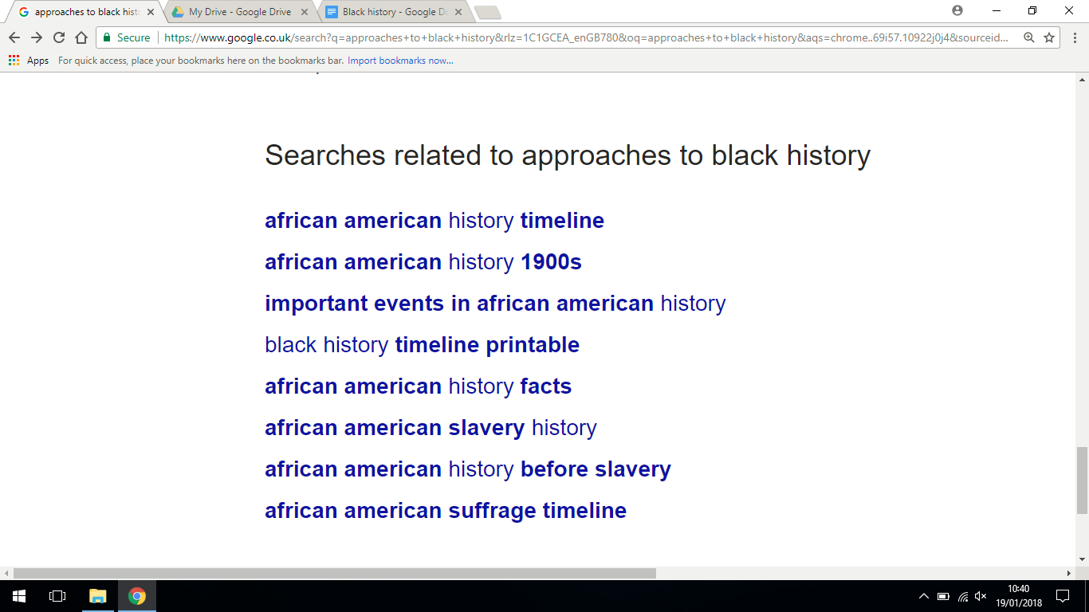
Questionable Black History in the British Curriculum  Article | Strong argument to the article focusing on bringing in black history as compulsory on the national curriculum. Article argues that the curriculum ignores the humanity of black people and only focuses on specific/key events. | http://africanstudies.org.uk/2017/01/14/questionable-black-history-in-the-british-curriculum/
Teaching Slavery  Article | Useful article for primary school education, but it includes some decent do and do not guidelines that can offer some useful direction when considering the teaching of slavery, a key component of black history. Especially the idea that a deficit model should not be taken when teaching this topic. | https://www.history.org.uk/primary/resource/2811/teaching-slavery
Can Art Amend History?  Ted Talk | Artist Titus Kaphar makes paintings and sculptures that wrestle with the struggles of the past while speaking to the diversity and advances of the present. Kaphar takes a brush full of white paint to a replica of a 17th-century Frans Hals painting, obscuring parts of the composition and bringing its hidden story into view. | https://www.ted.com/talks/titus_kaphar_can_art_amend_history
Harvard University: Project Implicit | Project Implicit is a non-profit organization and international collaboration between researchers who are interested in implicit social cognition - thoughts and feelings outside of conscious awareness and control. The goal of the organization is to educate the public about hidden biases and to provide a “virtual laboratory” for collecting data on the Internet. | https://implicit.harvard.edu/implicit/takeatest.html
National Archives - Resources Bank | Information on Black and Asian presence in British History as evidenced through the National Archives. | http://www.nationalarchives.gov.uk/pathways/blackhistory/index.htm
Black Presence in Britain - | A website with different posts about the lives of black people in British history, with reading recommendations. | https://blackpresence.co.uk
Book | David Olusoga ‘Black and British: A Forgotten History’ (2016).  An exploration of the long relationship between Britain and people whose origins lie in Africa. | 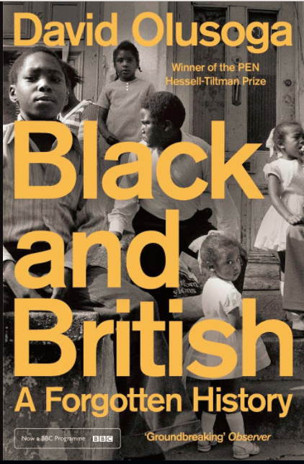
Young Historians Project | Young historians of African and Caribbean heritage | https://www.younghistoriansproject.org/ and specifically their work on the NHS: https://www.younghistoriansproject.org/african-women-and-the-health-servic

Germany 1933-1945 resources
- Could include more Black British/German experiences when discussing survivors
- Could discuss anecdotes such as Hitler and Jesse Owens (Olympic Games 1936)
- Could emphasis the eugenics programme behind Nazi ideology, rather than solely anti-semitism, possibly through the history of German genocidal atrocities pre-Nazi regime (such as the Herero Genocide 1904/genetic experiments in colonial Africa/Namibia). This could be a way into Gerlach’s Extremely Violent Societies theory, as a way to explain the conditions that facilitate genocide.
- Sterilisation projects, particularly against mixed-race children in the Rhineland, is a good example of genocidal acts that do not constitute killing, coming from a perspective that considers genocide a programme of cultural dismemberment, not simply immediate physical eradication of a race.

Sources | Details | Link
Article | Details a brief history of black people under the Nazi regime | https://www.ushmm.org/wlc/en/article.php?ModuleId=10005479
Article | Making Visible the Invisible: Germany's Black diaspora, 1880s -1945 | https://www.shu.ac.uk/research/in-action/projects/being-black-in-nazi-germany
Article | Brief overview from the Holocaust Memorial Day Trust | http://hmd.org.uk/genocides/black-people
Article | Overviews of German Genocidal activity in Colonial Africa | https://www.timesofisrael.com/in-germanys-extermination-program-for-black-africans-a-template-for-the-holocaust/  https://mg.co.za/article/1997-09-26-hitlers-forgotten-black-victims
Book | Dr. Constantine Simms, University of Essex, review of the documentary Hitler’s Forgotten Victims. Good critical summary of black experience in the Holocaust. | https://legacy.chass.ncsu.edu/jouvert/v1i2/DELROY.HTM
Book | Robert Kesting “The Black Experience of the Holocaust” in The Holocaust and History: the known, the unknown, the disputed and the re-examined, ed. Michael Berenbaum and Abraham J. Peck | https://books.google.co.uk/books?id=zkZC6bp3upsC&pg=PA361&lpg=PA361&dq=Lari+Gilges&source=bl&ots=9vV3bOQ-Vo&sig=iTIHkAQv8SBHQf28qyen2zX1W_g&hl=en&sa=X&ved=0ahUKEwjRy6a57OPYAhVKuhQKHfIaADoQ6AEIZDAO#v=onepage&q=Lari%20Gilges&f=false
Book | Black Germany: The Making and Unmaking of a Diaspora Community, 1884-1960 by Eve Rosenhaft and Robbie Aitken | https://books.google.co.uk/books/about/Black_Germany.html?id=NQFeAwAAQBAJ&source=kp_book_description&redir_esc=y
Journal Article | Robert W. Kesting, Forgotten Victims: Blacks in the Holocaust. Journal of Negro History, 78, 1 (1992) pp. 30-36
Journal Article | “Undesired intimacy: German–Chinese couples in Germany” (1900s–1940s)  Discusses Nazi opposition to Chinese-German marriages, and touches on the Chinesenaktion, a 1944 series of raids and arrests of Chinese nationals. | https://doi.org/10.1080/1081602X.2019.1630292
Book | Mein Kampf - Chapter 11: Race and People | https://en.wikiquote.org/wiki/Mein_Kampf#Chapter_11_-_Race_and_People
Survivor Profiles
Selection of profiles: https://www.huffingtonpost.com/chika-oduah/the-afrogerman-experience_b_9234700.html

Hilarius Gilges | Murdered by the SS - marked as the first murder in Dusseldorf. Plaque was set down in 2003, not far from one commissioned in 1988 to commemorate the life of the slain Afro-German. | 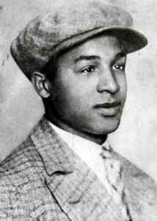

Article/book | Case study of Hans Massaquoi who survived the Nazi regime “because of a loophole in the law”  His memoirs: Massaquoi, Hans (2001). Destined to Witness: Growing Up Black in Nazi Germany. New York: HarperCollins. ISBN 0-06-095961-4. | https://www.vice.com/en_uk/article/qbxmyx/black-nazi-brais-iglesias-castro-929  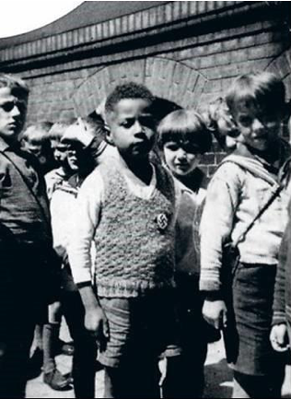
Article/book | Mahjub bin Adam Mohamed: First black victim of the Holocaust to have an individual memorial outside his house in Berlin - he was also accused of racial inter-marriage under the Nazis for marrying a German woman.  Book: Truthful Till Death, by Marianne Bechhaus-Gerst | https://www.theguardian.com/world/2007/sep/16/secondworldwar.germany
Book | Hitler’s Black Victims, Clarence Lusane  Analyses Nazi racial policies towards people of African descent, mostly through the experience of survivors | https://www.amazon.co.uk/Hitlers-Black-Victims-Afro-Germans-Crosscurrents/dp/0415932955
Documentary | Hans Hauck (survivor) - example of sterilisation (genocidal acts without murder.)  Documentary in conjunction with David Okuefuna examining the plight of black and mixed race people in Germany during the Third Reich - mostly the ‘Rhineland Bastards’ and programmes of child sterilisation. | Black Victims of the Holocaust - also called Hitler’s Forgotten Victims  https://en.wikipedia.org/wiki/Hans_Hauck
Visual Sources
Gallery | Small collection of photos spanning black involvement in propaganda, camps, the army + liberation. | https://www.ushmm.org/wlc/en/gallery.php?ModuleId=10005479&MediaType=ph  E.g. 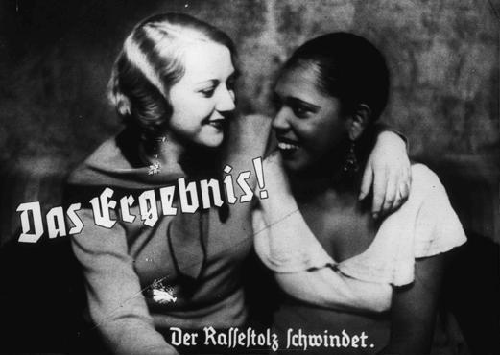

Early Modern History

Source | Details | Link
Interactive Map | This UCL map offers nothing more than the raw data of slave ownership based on addresses within the UK. It is a useful tool that should be used in conjunction with other information rather than allowing it to stand on its own. | https://www.ucl.ac.uk/lbs/maps/britain/#zoom=8&lng=-0.851440&lat=51.757640
Book | Black Lives in the English Archives, 1500-1677, Imtiaz Habib
Article  Book | Out of Africa: Stories of pioneering black in Early Modern England, Miranda Kaufmann (University of London)  Kaufmann discusses her book, Black Tudors | https://london.ac.uk/news-and-opinion/leading-women/out-africa-stories-pioneering-black-women-early-modern-england
Author website | Miranda Kaufmann website about black Tudors, Stuarts, Georgians  Art | http://www.mirandakaufmann.com/blog/find-out-more-about-black-tudors-stuarts-and-georgians-this-black-history-month
BBC article | Britain’s first black community in Elizabethan London | https://www.bbc.co.uk/news/magazine-18903391
History website | Black History Milestones  Clearly focuses on black history in the United States. Unfortunate start at slavery, but the information beyond can be useful. | https://www.history.com/topics/black-history/black-history-milestones
Institute of Historical Research | Range of sources: personal narratives (letters, diaries etc), travel writing, government and official sources, newspapers, maps | https://www.history.ac.uk/library/collections/black-history#personal-narratives
Book | Gretchen Gerzina, Black England: Life Before Emancipation  Book looks at black people in England in the 18th century
Book | Shyllon, Black People in Britain 1555-1883
Article | Black Tudors, a peek into the lives of ten people of the African Diaspora who lived in Tudor Britain | https://www.blackhistorymonth.org.uk/article/section/author-and-historians/black-tudors-a-peak-into-the-lives-of-ten-people-of-the-african-diaspora-in-tudor-britain/
English Heritage | Georgian England black history | https://www.english-heritage.org.uk/visit/places/portchester-castle/history-and-stories/black-people-in-late-18th-century-britain/
Film | Belle (2013) inspired by painting of Dido Elizabeth Belle (fictional film)
Painting | Painting of Dido Belle (mixed race) | https://www.theguardian.com/artanddesign/2014/may/27/dido-belle-enigmatic-painting-that-inspired-a-movie
Historical Association article | Jane Card o the portrait of Dido Belle and Elizabeth Murray | https://www.history.org.uk/publications/resource/8541/the-power-of-context-using-a-visual-source
Article | Black Lives Matter  A useful article for a concise history of the movement itself | https://www.britannica.com/topic/Black-Lives-Matter
Article | How Black Lives Matter is Changing Black History Month  Another useful insight on how BLM has affected education in the United States’ approach to the teaching of black history. | https://time.com/5771045/black-history-month-evolution/
Article | Religious minorities, vagabonds and gypsies in early modern Europe  ‘Minority Ethnic’ for this section covers a wide variety, and while Roma-Gypsies will have already been covered in this document it is clear that this article offers a useful insight on the development of a shifting perception of ethnic minorities as well as other smaller groups within societies of the early modern period. | https://books.openedition.org/ceup/1411?lang=en
Black Presence up to Tudor Times  Lesson resources | Evidence of 360 African individuals in the British Isles between 1500-1640. | http://www.blackhistory4schools.com/tudors/
Kew Palace History and Stories  Website | Story of Queen Charlotte, possibly Britain’s first black queen in C18-19th. | https://www.hrp.org.uk/kew-palace/history-and-stories/queen-charlotte/#gs.p52lln

Medieval
Source | Details | Link
Article | National Archives  John Blanke, a royal trumpeter and possibly attached to the retinue of Catherine of Aragon. Paid 8d a day by Henry VII and then Henry VIII. | http://www.nationalarchives.gov.uk/pathways/blackhistory/early_times/blanke.htm  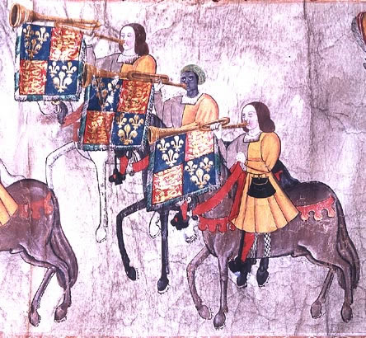
Exchequer Roll 1507 showing payment to John Blanke | 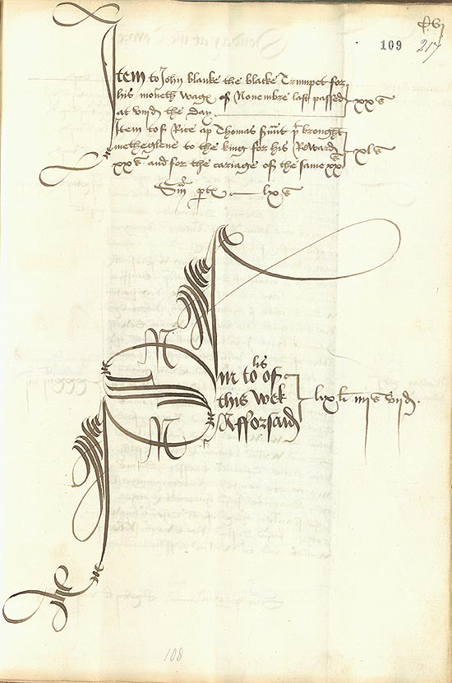 | http://www.nationalarchives.gov.uk/pathways/blackhistory/early_times/docs/blanke_payment.htm
Images | African presence in the Domesday Abbreviato (one of the three condensed versions of the Domesday Book) produced in the thirteenth century. | https://www.ourmigrationstory.org.uk/oms/an-african-presence-in-the-thirteenth-century
Video Clip | Ted-Ed - Introduction to Mansa Musa. Jessica Smith. | https://www.youtube.com/watch?v=O3YJMaL55TM
Website | Information about the Ipswich Man, a black man of probable Tunisian origin whose remains were found in the ruins of a monastery in Ipswich. | Evidence for Medieval Black History in England » (decodedpast.com)
Article | Ethnic Identification and Stereotypes in Western Europe, circa 1100-1300  This article delves into the race relations and their developments within Western Europe in the medieval period. It is a useful piece for dissecting the origins of race relations in the past which feeds into ethnic minorities within history | https://core.ac.uk/download/pdf/141518825.pdf

Romans and Ancient Civilizations
The Roman Empire - Britain included - was culturally and ethnically diverse.

- “In the first of those processes the chapters of the British history in which the fates, status and humanity of black people had been critical and central - those dealing with British Slavery and empire in Africa - had been marginalized and quarantine into historical specialisms. In the second process the story of the long presence of black people within Britain itself had been rendered almost invisible.” p18 (David Olusoga, 2016)
- Note that it was Roman Imperialism that was the force that first brought the first Africans to Britain, long before the British colonial act brought the British to Africa.
- Emphasise that Roman perceptions of Race should not be perceived through the lens of modern understandings. Romans status was far more tied to citizenship (and gender) than Race, origin or sexual orientation. Septimius Severus came from Numidia.

Source | Details | Link
Image | Evidence of a woman of mixed African heritage in Roman York. | 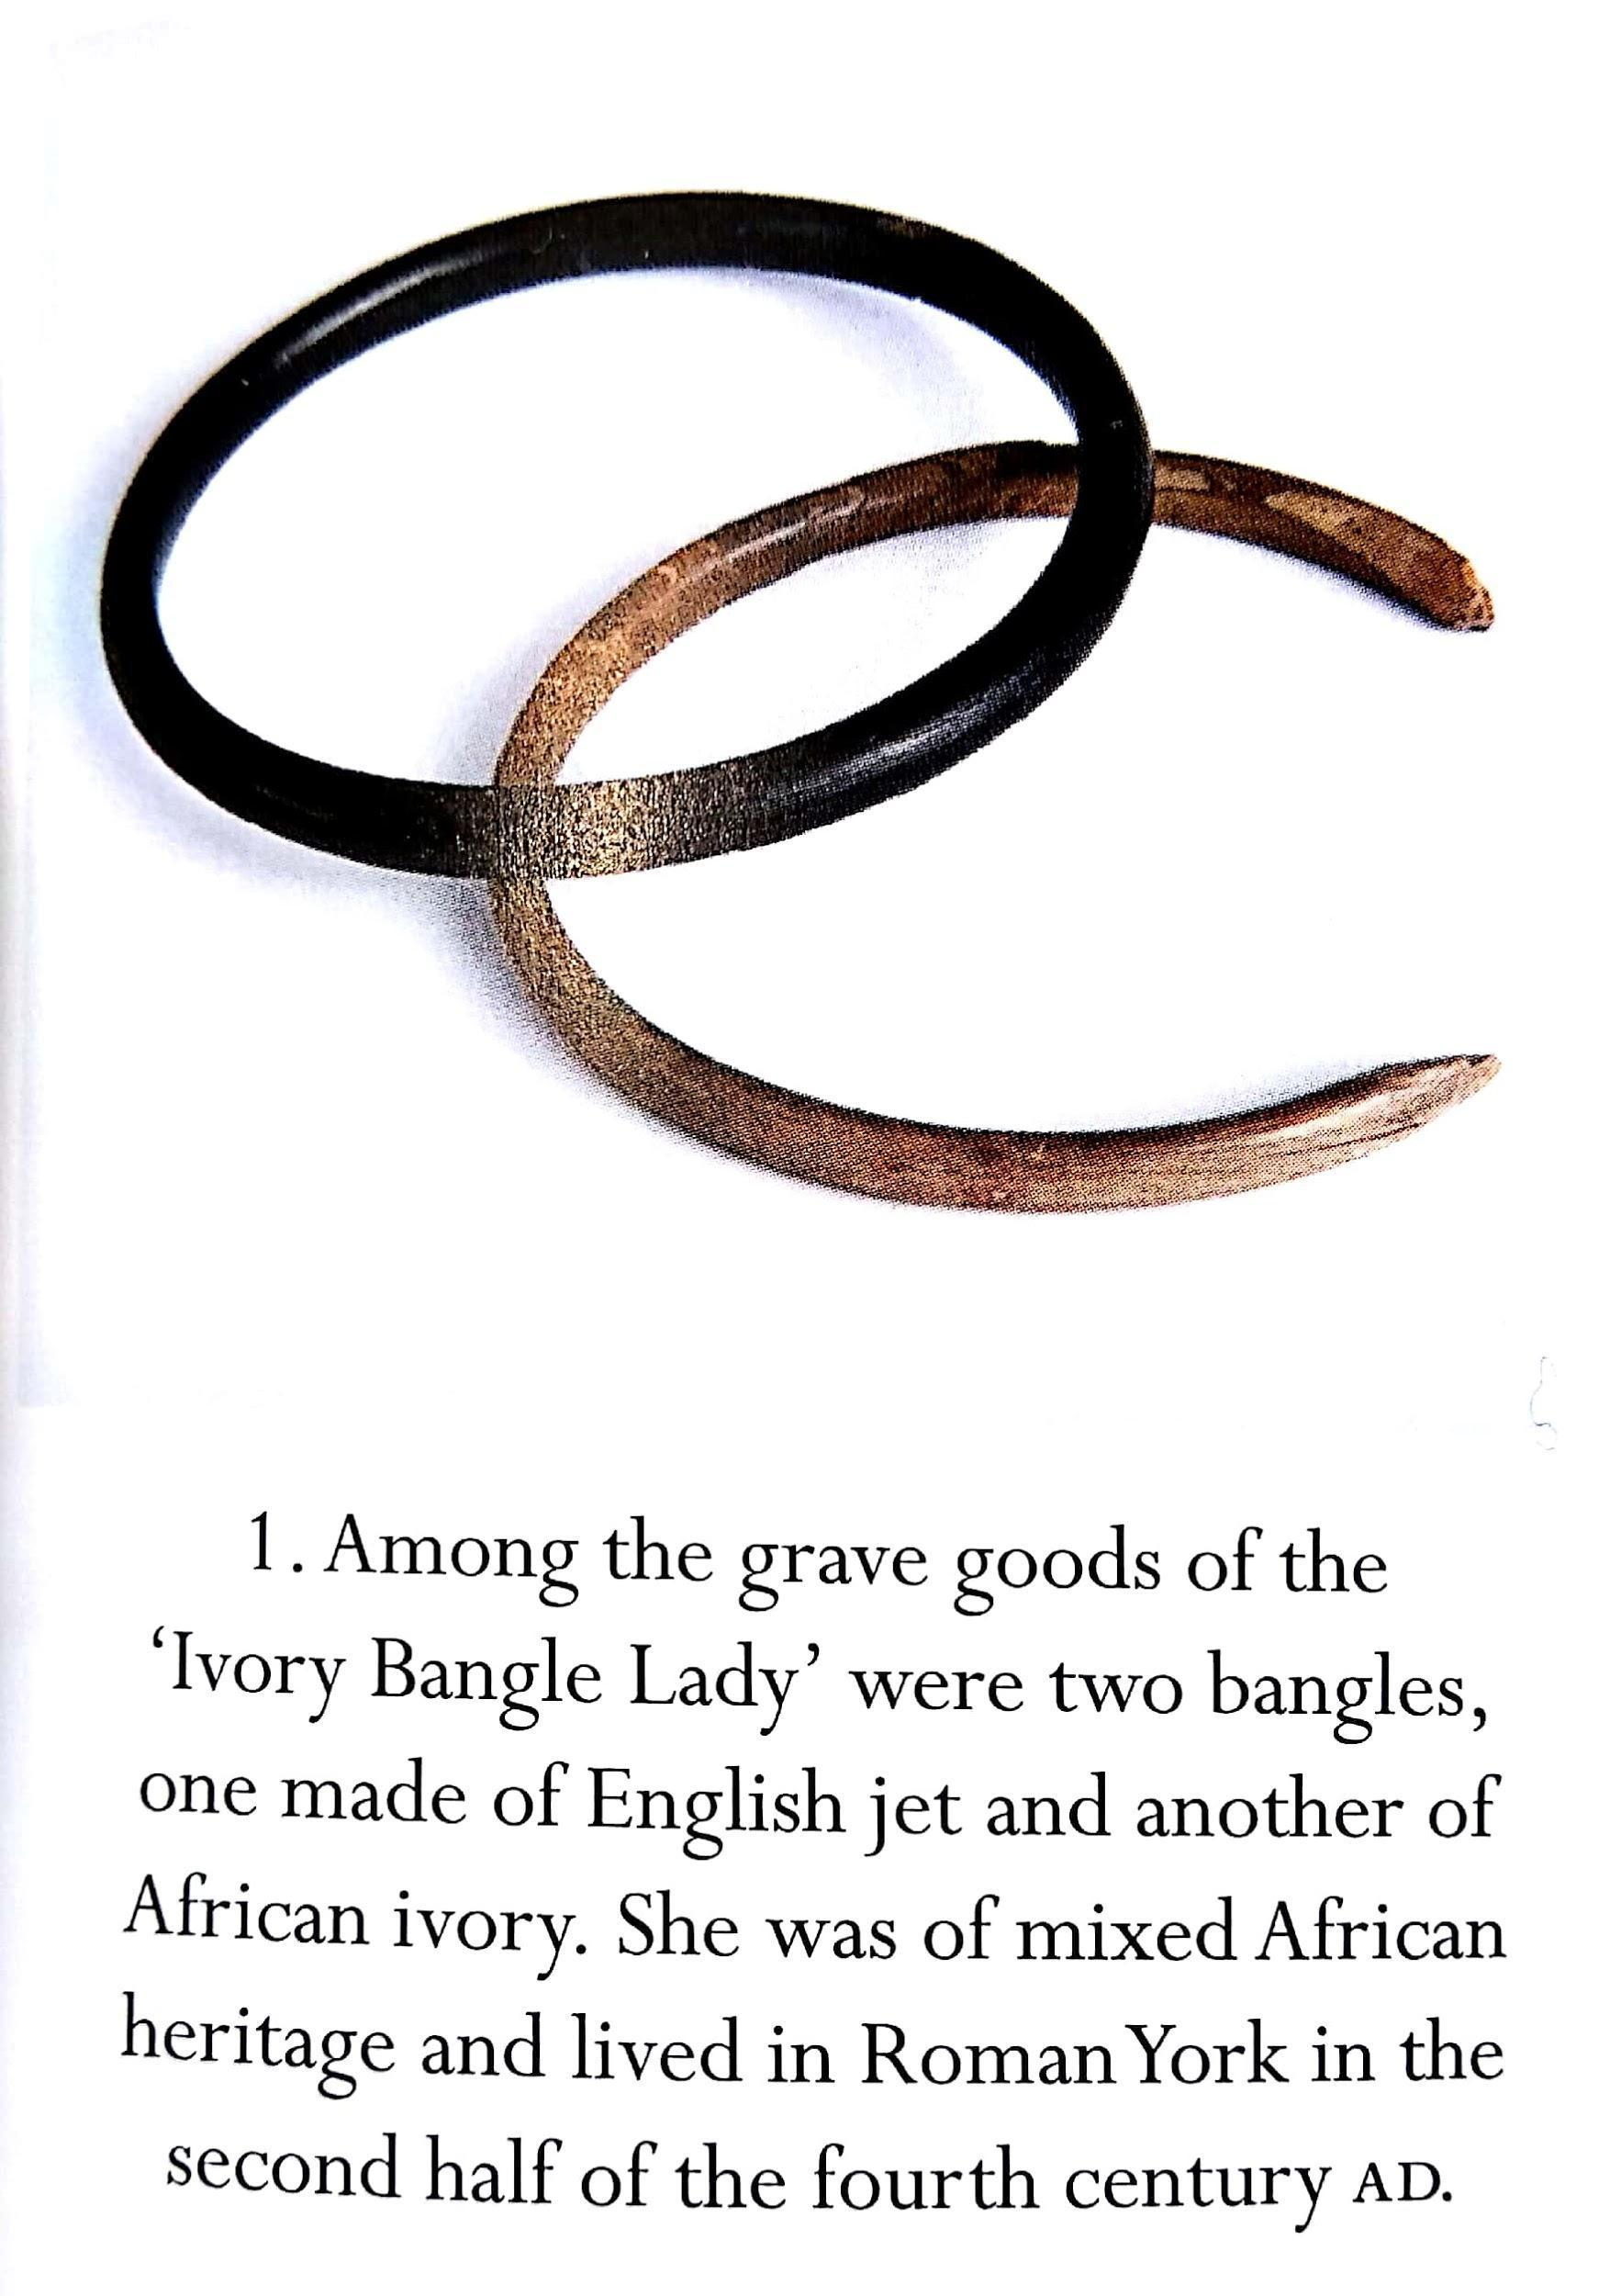
Story/website | Details on the story of the Ivory Bangle Lady’s migration to Britain. | https://www.ourmigrationstory.org.uk/oms/roman-britain-the-ivory-bangle-lady
Video Clip - BBC | KS3  Life in Roman Britain as seen through the eyes of one family nearly 2000 years ago. | http://www.bbc.co.uk/programmes/p01zfw4w
Sculpture/Tombstone | Tombstone is evidence for the immigration and cultural mixing - found outside a Roman fort in South Shields (NE England)  Tombstone - Regina who originally came from Palmyra (Syria) Regina was a slave and was freed by Barates who then married her. The inscription is in Latin and Aramaic (Regina’s first language) reading ‘Regina, freedwoman of Barates, alas” N.b. This inscription is unique to Roman Britain. | http://www.bbc.co.uk/ahistoryoftheworld/objects/EBvs4GUaT8Knfhl_sSpGWw  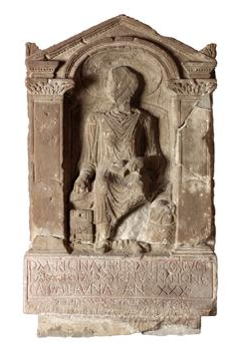
Video Clip | Discovering the first ‘Black Briton’ and race in the Roman Era. David Olusoga and Mary Beard. | https://www.youtube.com/watch?v=v4oIXLBoi0Q
Video Clip | Western reactions to Benin Bronzes. David Olusogsa. | https://www.youtube.com/watch?v=rp8flCwvoAU
Online Article | Roman Slavery and the question of race.  The article examines slavery in the Roman Empire and racial sterotypes. | https://www.blackpast.org/global-african-history/perspectives-global-african-history/roman-slavery-and-question-race/
Online Article | How Ethnically diverse was Roman Britain.  Questions and answers regarding ethnic diversity in Roman Britain. | https://www.historyextra.com/period/roman/how-ethnically-diverse-was-roman-britain/

Polish history
There are many Polish children and children of Polish heritage in British classrooms. Yet Poland as a country may only appear in the history classroom when it is violated by the USSR and Nazi Germany, and when Nazi Germany’s death camps are established in Poland. There has also been a long history of Polish migration to Britain and so many Polish people have shaped Britain.
Some resources to help bring Poland and Polish people into your classroom are here: https://instytutpolski.pl/london/education/

Disability history in your classroom

Resources have been developed that will enable you to carry out a mini-thematic study at Key Stage 3 of the history of disability, in order to introduce the idea of thematic study ready for GCSE. It will enable KS3 students to develop their knowledge of the concepts of change and continuity and chronology. It also complements the GCSE history of medicine studies that are popular. You can find them here: https://yorkclio.com/2018/05/19/hidden-in-plain-sight-resources-for-teaching-the-history-of-people-with-disability/

You can find a lesson using archival material to investigate some of the history of mental health here: https://yorkclio.com/2019/05/17/teaching-a-history-of-mental-health-to-improve-thematic-understanding-in-a-packed-curriculum/

In addition there are a growing number of ‘slot-ins’ about specific people with disability and events related to disability that will be easy to incorporate to your existing schemes of work. For example, the slave trade and abolition, and also the Cold War. There are here: https://yorkclio.com/slot-ins/

TH173 December 2018 has an article (https://www.history.org.uk/publications/resource/9503) that includes principles for teaching this topic. For further resources on the history of mental health see the HA conference May 2019.

A useful resource for teachers about people with disability in Britain across time has been put together as Historic England: https://historicengland.org.uk/research/inclusive-heritage/disability-history/

Invisible Disability Project https://www.invisibledisabilityproject.org/
Discusses the historical origins of the term ‘invisible disability’, one that seems to have originated during the early part of the C20th, in part to address the concerns of soldiers returning from WWI who suffered from shell shock.

Learning disability
An important new project website is here: http://www.learningdisabilityhistory.org/

Mental health
- Life writings of self-perceived mentally ill women in the early modern period:
- Dionys Fitzherbert, ed. Katharine Hodgkin,​ Women, Madness and Sin in Early Modern England: The Autobiographical Writings of Dionys Fitzherbert (​Ashgate Publishing ,Ltd.,2010)
- Hannah Allen, A​ narrative of God's gracious dealings with that choice Christian Mrs. Hannah Allen (afterwards married to Mr. Hatt,): reciting the great advantages the devil made of her deep melancholy, and the triumphant victories, rich and sovereign graces, God gave her over all his stratagems and devices.(​London: Printed by John Wallis, 1683)
- Burton, Robert. T​he Anatomy of Melancholy,​ ed. W. J. Widdleton, New York (1870). An informative text from the Early Modern period. A treatise intended to document symptoms and cures of the historical condition ‘melancholy’.

Current scholarship

- Kudlick - Disability History: Why we need another “other” (2003) - details where the field has gone, and also justifications for centrality of disability history.
- Irene Metzler is the leader in this field. E.g. A social history of disability
- Key discussions include how we define disability vs impairment; autism; leprosy; blindness.

What is Colonial about Colonial Medicine? And What has Happened to Imperialism and Health? | Social History of Medicine | Oxford Academic
Shula Marks
Social History of Medicine Volume: 10
- “Introduction: Disability, Normality and Power”, The Disability Studies Reader by Lennard J. Davis - https://ebookcentral.proquest.com/lib/york-ebooks/detail.action?docID=1125176
An introduction to the idea of normativity and its current role in society. Helpful when considering our current standpoint on disease and disability before thinking about how the idea of the ‘normal’ affects historical scholarship and sources.

History of Down’s Syndrome:
https://www.downs-syndrome.org.uk/about/history-of-downs-syndrome-2/?gclid=CjwKCAiA0svwBRBhEiwAHqKjFqJCXWR96vEhO_SL0psraMyluIvHjtK5bii8IPuLh5nH5Vd_3au1ZhoCjwQQAvD_BwE
Includes a video of the legacy of Langdon Down
https://www.downs-syndrome.org.uk/about/terminology-guide/
Terminology guide from the Down’s Syndrome Association

https://www.livescience.com/46721-earliest-down-syndrome-skeleton-discovered.html
Study in to the earliest probable case of Down’s Syndrome.

https://globaldimension.org.uk/event/gypsy-roma-and-traveller-history-month/2017-06-01/
https://www.natt.org.uk/community-information/gypsy-roma-and-traveller-communities/
http://www.sintiundroma.de/en/sinti-roma.html

